**UNIVERSITY COLLEGE OF ENGINEERING (BIT CAMPUS), TIRUCHIRAPPALLI-620 024**

**Third Internal Assessment Test**

**Department of CSE / IT**

**Subject Code / Name:** CS8492 / Database Management Systems

**Date Duration : 20.03.2019**& 1.30Hrs **Marks: 50**

**Degree/Branch:** B.TECH/IT Sec’B’ **Year / Sem:** II / IV

**ANSWER KEY**

**PART-A**

**Answer *All* Questions 7 x 2 = 14**

1. **What is a B+ tree index file in DBMS?**

If the records are stored using this concept, then those files are called as B+ tree index files. Since this tree is balanced and sorted, all the nodes will be at same distance and only leaf node has the actual**value**, makes searching for any record easy and quick in B+ tree index files.

1. **Point out the methods for implementing JOINs.**

Three **join strategies** are available **to** the query processor: nested loops, ... When **executing** a nested-loop **join**, SQL Server scans the outer table row by row. ... the second input must be positioned **to** the **point** in the database where the first ...

1. **Contrast sparse index and dense index.**

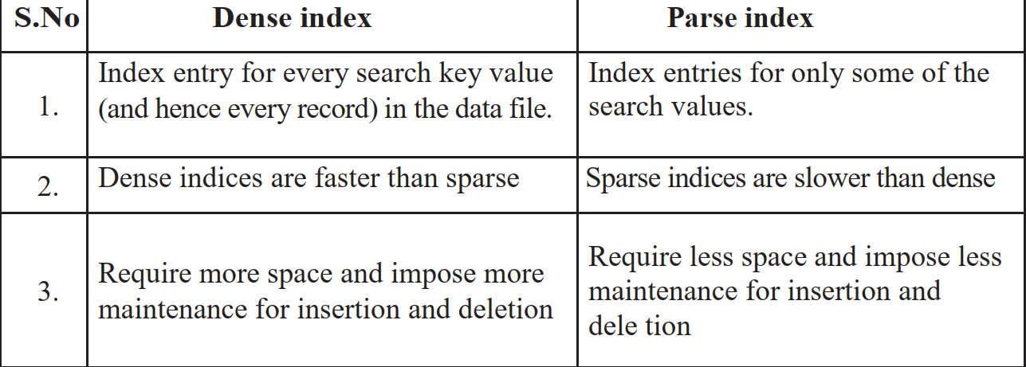

1. **Explain “Query Optimization” with your own database.**

**Query optimization**. **Query optimization** is a function of many relational **database**management systems. The **query** optimizer attempts to determine the most efficient way to execute a given **query** by considering the possible **query** plans.

1. **Compare information retrieval Vs DBMS.**

1.A major strength of the DataDefinitonLanguage of DBMS is the capability to define the dataintegrity constraints.In IRSs such validation mechanisms are less developed.

2. DBMSs provides precise semantics.IRSs most of the time provides imprecise semantics.

3. DBMSs has structured data format.Wereas, IRSs is characterised by unstructured data format.

4. Query specification is complete in DBMS.In IRS query specification is incomplete.

5. Query language is artificial in DBMS.In IRS query language is near to natural language

1. **Show how are transaction performed in Object oriented database?**

A transaction is a program that is either executed entirely or not executed at all. This is called atomicity; transactions are atomic. If the user performs updates to the [persistent database](http://www.perflensburg.se/Privatsida/cp-web/PERSKHOS.HTM) within a transaction, then either all of the updates must be visible to the outside world or none of the updates must be seen. In the former case it is said that the transaction has been committed. In the latter case we say the transaction has been aborted. According to the authors, [database management systems](http://www.perflensburg.se/Privatsida/cp-web/DAAPDAOL.HTM) must support atomic transactions. [Object-oriented databases](http://www.perflensburg.se/Privatsida/cp-web/OODBKHOS.HTM) are geared toward engineering and design applications. Nested transactions provide a more direct support of project development for these applications.

1. **What are ODL and OQL.**

Operations defined in OQL can be defined in the ODL. ODL is intented to define object types that can be implemented in a variety of programming languages. ... EYEDB ODL differs from ODMG ODL from several points: ODMG ODL defines class attributes, relationships, method signatures and keys.

**PART-B**

**Answer any three Questions 3 x 10 = 30**

1. **Develop a B+ tree to insert the following key elements**

**(order of the tree 3) 5,3,4,9,7,15,14,21,22,23.**

1. **Write short notes on**
2. **Discuss briefly about B+ tree index file with example**

* The B+ tree is a balanced binary search tree. It follows a multi-level index format.
* In the B+ tree, leaf nodes denote actual data pointers. B+ tree ensures that all leaf nodes remain at the same height.
* In the B+ tree, the leaf nodes are linked using a link list. Therefore, a B+ tree can support random access as well as sequential access.

Structure of B+ Tree

* In the B+ tree, every leaf node is at equal distance from the root node. The B+ tree is of the order n where n is fixed for every B+ tree.
* It contains an internal node and leaf node.

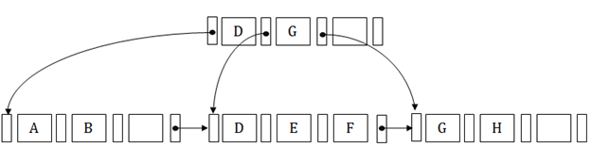

Internal node

* An internal node of the B+ tree can contain at least n/2 record pointers except the root node.
* At most, an internal node of the tree contains n pointers.

Leaf node

* The leaf node of the B+ tree can contain at least n/2 record pointers and n/2 key values.
* At most, a leaf node contains n record pointer and n key values.
* Every leaf node of the B+ tree contains one block pointer P to point to next leaf node.

1. **How does a B-tree differ from a B+ - tree? why is a B+-tree usually preferred as an access structure to a data file?**

Deletion of internal nodes is very complicated. In a**B+ tree**, **data** is only found in leaf nodes. ... In a **B+ tree**, leaf nodes **data are** ordered as a sequential linked list but in **B tree** the leaf node cannot be stored using a linked list. Many database systems' implementations prefer the structural simplicity of a**B+ tree**.

1. **i) Describe in detail about Object Model of ODMG.**

Major components of the ODMG 3.0 specification. ... The ODMG Object Definition Language (ODL) was used to define the object types that conform to the ODMG Object Model. The ODMG Object Interchange Format (OIF) was used to dump and load the current state to or from a file or set of files. Object Query Language (OQL).

**ii)** **Illustrate the concepts for information retrieval.**

**Information retrieval**. ... **Information retrieval** is the science of searching for **information** in a document, searching for documents themselves, and also searching for metadata that describe data, and for databases of texts, images or sounds.

1. **i) Explain the features of object relational**

* **User Data Types & Complex Objects**
* **Inheritance**
* **Method Encapsulation**

**ii) Examine the process of querying XML data with an example.**

XQuery is a standardized language for combining documents, databases, Web pages and al- most anything else. It is very widely implemented. It is powerful and easy to learn. XQuery is replacing proprietary middleware languages and Web Application development languages.  
XQuery is replacing complex Java or C++ programs with a few lines of code. XQuery is sim- pler to work with and easier to maintain than many other alternatives.

* XQuery is a functional language. It is used to retrieve and query XML based data.
* XQuery is expression-oriented programming language with a simple type sys- tem.
* XQuery is analogous to SQL. For example: As SQL is query language for data- bases, same as XQuery is query language for XML.
* XQuery is XPath based and uses XPath expressions to navigate through XML documents.